Feedback and Marking Policy

Policy Leader: | Paul Slater
Policy agreed by governors: | Summer 2026

- The purpose of giving Feedback

Having read the April 2016 EEF review paper ‘A marked improvement?’ which carefully considers what feedback teachers give to pupils, we have agreed that marking is only a small part of the overall feedback we give to our pupils to support their own individual improvement and progress across all subjects.

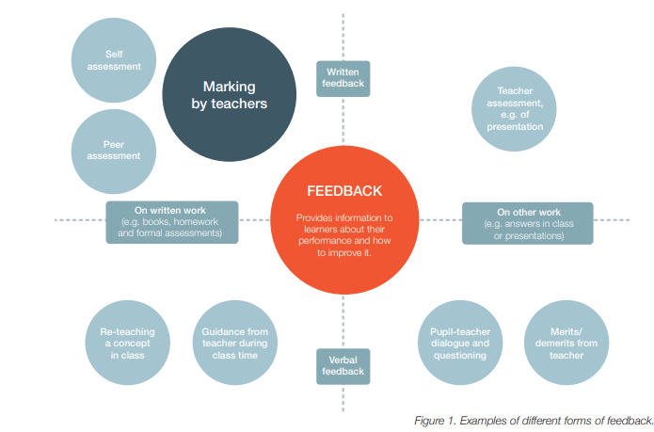

Whilst marking is one form of feedback, it is clearly not the only one and as a good school with a focus on pupils being able to self-motivate and self-improve alongside the guidance and advice of teachers we want to ensure that we employ as many of the different forms of feedback as possible in a sustained and manageable way which causes the most effect for pupils. We put a real focus on promoting autonomy: Students learn to take responsibility for and manage their own learning.

- How we give feedback

It has been agreed that the most effective and impactful feedback in our school is by giving verbal feedback to children as they are involved in their learning. If this is not possible during the actual learning situation, then verbal feedback remains the most effective at the beginning of the next session where a teacher can review, with the child, what has been accomplished and what needs attention for improvement.

Teachers will therefore give children more verbal feedback on their work than through actually marking work. Teaching staff will place an emphasis on identifying errors being made by pupils (individually, as a group or as a class) during lessons and give ‘in-the-moment’ feedback to correct those errors and misconceptions.

Marking will be restricted to simple guidance toward correcting errors and highlighting these with advice on what needs to be done to correct them. Staff may also add simple phrases of encouragement to marking when appropriate.

The school has a clear and simple marking code which teachers and pupils use and understand, and any response to marking is done verbally during the next session. Teachers will then continue to give verbal feedback to the children during the lesson.

- The gains for pupils from feedback

Pupils acknowledge that they like to get regular feedback on their learning in all subjects as this keeps their interest and they want to learn from their errors instead of repeating them. Through marking we aim to:
- Support pupils to make progress
- Support pupils to identify their own errors and self-correct where possible
- Provide context and clear examples of how to correct mis-conceptions and errors
- Enable pupils to make good progress during all lessons towards expected levels for their year group, and beyond
- Improve self-confidence and self-esteem through verbal feedback 1-1 or in small groups rather than through negative marking practices
- Engage pupils in their own learning and development and challenge themselves at all times

- The mechanics of feedback

Teachers will aim to provide verbal feedback and marking during lessons when independent or group activities are being completed so that any mis-conceptions or errors that are being made can be corrected immediately and teaching points can be covered again where appropriate. This may include 1-1 teaching sessions within the lesson, or in small groups or as a whole class if the misconception is class-wide. Simple marking will be completed at the same time.

Any pupils or books that have not been seen during that session will then be checked at the end of the lesson and simple marking will be completed and verbal feedback given at the beginning of the next session. Teachers will use the coding system to indicate errors for children to correct. These will be initially be indicated on the errors themselves but will gradually be indicated in the margin on the same line as the mistake and so promoting children’s independence towards actively identifying and correcting their own errors.

Teachers also recognise and feedback to pupils on effort and behaviour for learning and this may be indicated through simple written feedback in books, through verbal feedback ‘in-the-moment’ or through the use of stickers or stamps. A stamp may also be used to indicate when an objective has been achieved in order to give clarity to the pupil that they have achieved the learning.

Class Dojo will also be used to record progress, attainment and attitude towards learning and this will be shared with parents/carers through the app.

At times, pupils are encouraged to evaluate others’ work and receive critical feedback on their own work, again using the simple marking methods and making sure the feedback is mainly verbal and linked to the learning objective. Utilising talk partners within all subject areas further strengthens our emphasis on a achieving a quality piece of work.

Teachers are expected to ensure that spelling, grammar and punctuation errors are highlighted at all times as long as it does not detract from the overall work (ie. Not highlighting them all if there are a high number of errors). Teachers should then expect pupils to learn from their errors and add spelling errors to their weekly spelling lists and to check their next piece of work so that grammar and punctuation errors are not repeated.

- Outcomes from feedback

Feedback and simple marking may result in teachers setting other work for pupils to complete at home to support their learning but this will be limited to simple tasks which support a clear and defined objective. For example, teachers may ask a pupil to complete a number of simple two-digit additions as homework; or may ask pupils to practise spellings they have done incorrectly and put them into a sentence as part of their homework.

Pupils will be reminded at the beginning of any session to consider the feedback they have been given and to ensure that they do not repeat errors or ask for support to remind them where they went wrong previously.

From feedback, teachers will be able to assess learning attainment and progress of all pupils and adapt lessons accordingly as well as record pupils’ overall attainment in all subjects over the topic and the year.

- Review

This policy will be reviewed annually.

Simple Marking Scheme

 | Tick when correct answer given
x | Cross when wrong  teacher to stop after a few errors
Stamp used | Objective met and/or good attitude towards learning seen
O | Around mistake such as spelling, grammar, punctuation, expectation is for this to be corrected at the beginning of the next session

