Ventilation Inspection Checklist 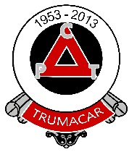 |  |  | 
Premise/School | Trumacar Nursery and Community Primary School | Name of person(s) undertaking the inspection checklist | Paul Slater  Anthea Collin
Date checklist completed | 17th January 2026 | Review dates | September 2026

This inspection checklist has been developed based on increasing evidence that ventilation is one of the key ways to reduce the spread of Coronavirus. It should be used in conjunction with the county councils guidance on simple steps to good ventilation available on the intranet and the school portal and the premises local COVID-19 secure workplace risk assessment. Completion of the checklist requires consideration of every room within the building to identify and assess the suitability of the ventilation. To help you in this task, examples of ventilation types are provided at the end of this document.

Once completed the checklist should be reviewed twice a year to take account of the change in seasons or in the event of any changes/upgrades etc in ventilation systems. October and March are recommended as appropriate review dates.

A copy of the completed checklist should be retained with your building or COVID Secure Risk Assessment.

Ventilation Types
Natural  Air flow through openings such as doors (ideally external) and windows.  - Ensure windows are opened regularly to allow sufficient air flow, ideally leave them open a little throughout the day.  - Doors should be opened when possible to ensure sufficient air flow or to purge the air after periods of high occupancy.  - In each case please consider the security of the building.  - If the room has automated windows/vents, ensure the controls are set to operate during occupied hours. |  |  | Mechanical - supply and extract  Outside air drawn into ducting by fans and inside air extracted out by fans.  - Consider how this is controlled. E.g. switched on as and when needed, on a timer or on demand via CO₂ monitoring.  - For either type ensure it comes on an hour before occupancy at a nominal speed.  - If it has a CO₂ monitor, ensure the set point has been lowered to operate the ventilation at to 400ppm.  Mechanical – extract only  Commonly used for toilet blocks and wet rooms. This type of ventilation should be set to run continuously during opening hours. |  |  |  | Mechanical - heat recovery  Extracts heat from indoor air to warm incoming outside air. Might recirculate a portion of the indoor air back into the room.  This type of ventilation is suitable for use, as long as it doesn't serve other rooms and there is the ability to increase the amount of outside air in the room.  Specialist localised exhaust ventilation  This includes cooker hoods, local exhaust on workshop machinery and fume hoods.  Do not use specialist localised extract ventilation systems without some additional means of supplying fresh air such as ability to open windows.
Mechanical – air conditioning
This type of ventilation may only condition the air and recirculate it within the same room. Such a system could be left to run, as this will prevent stagnation, but it may not be immediately obvious whether the system draws in fresh outside air to dilute any airborne pathogens. Premise Managers should consider the use of and access to the room and consult their Building Services Engineer or Appointed Building Consultant if they are unsure.

Rooms with Sufficient Ventilation – All rooms have natural ventilation except those identified below
Identify the type of ventilation in each room, if there is more than 1 type, identify each:  Natural (N)  Mechanical - supply and extract (MSE)  Mechanical - heat recovery (MHR)  Mechanical – extract only (MEO)  Mechanical – air conditioning (drawing in outside air) (MAC)  Specialist localised exhaust ventilation (SLEV)  No ventilation (NV)  Not known (NK)  Determining sufficient Ventilation  For rooms with mechanical or air con systems:  There must be no recirculation or transfer of air between one room to another.  Indicators of insufficient ventilation:  - Room feels stuffy or has a lingering odour.  - Room is small with limited outside air supply.  - Room is landlocked with only internal doors and no external windows/grills/vents.  When determining if the ventilation is sufficient, consider what the rooms are used for and by whom.  More ventilation is recommended in rooms where there is/are:  - physical activity.  - raised voices including singing.  - vulnerable people including the elderly.  - members of the public.  - inability to maintain other measures such as social distancing.  - regular changes in occupancy. | List all rooms where there is an obvious and effective source of ventilation including corridors and stairways and identify the ventilation type
 | Room No. | Ventilation Type | Transfer/Recirculation  of air?  Yes/No | Comments
 | 94. The Den | MAC | No | Serviced as per schedule and also Natural ventilation through windows and two doors to outside
 | 95. Ladies toilet | MEO | No
 | 96. Gents toilet | MEO | No
 | 62. Staff room store | Interior door | Yes | Door remains open into staffroom, and room is only used for collection and return of equipment
 | 61. Elec meter room | Interior door | Yes | Door remains closed unless access to electricity meter/supply required.
 | 60. Cleaner store | Interior door | Yes | Only used when equipment needed for cleaning
 | 56. Nursery kitchen | Interior door | Yes | Door kept half open to allow circulation of air from Nursery
 | 54. Nursery store | Interior door | Yes | Used for storage collection and return
 | 52. Disabled toilet | MEO | No
 | 134. EYFS Office | Interior door | Yes | Office door remains open majority of the time to ensure ventilation flow
 | 22A. Nurture Room | A/C Unit  Air Purifiers | Yes | These were installed in December 2022-early 2023

Rooms with Insufficient or No Ventilation
Indicators of insufficient ventilation:  - Room feels stuffy or has a lingering odour.  - Room is small with limited outside air supply.  - Room is landlocked with only internal doors and no external windows/grills/vents.  Consider what the rooms will be used for and by who.  More ventilation is recommended in rooms where there is:  - physical activity.  - raised voices including singing.  - vulnerable people including the elderly.  - members of the public.  - regular changes in occupancy.  - inability to maintain other measures such as social distancing. | List all rooms with insufficient or no ventilation  Room No. | Comments
 | 134. EYFS Office | Only 1 person working in there and mostly with door open onto Room 130 with access to fresh air from outside

Actions/Control Measures to Consider
You need to do all you can to ensure there is sufficient ventilation in each room within your building. The following provides examples of simple measures that can be taken to increase the ventilation in each room. Any control measures should also be documented in your building/COVID secure risk assessment.
Where necessary prohibit use of any rooms until further action is taken to improve ventilation.
If you have a CO₂ monitor, check levels of CO₂ in areas suspected of having poor ventilation. Where levels are consistently measured at more than 1500ppm, this is an indicator of poor ventilation and action is required to improve natural ventilation in the area. Your Building Services Engineer or Appointed Building Consultant will be able to advise on any action required or advise on the purchase of CO₂ monitors.
Turn off ventilation systems where they recirculate indoor air from one room/area to another.
Set mechanical ventilation to come on an hour before occupancy and an hour after or CO₂ setpoint lowered to 400ppm.
Restrict room occupancy in small rooms with limited outside air supply.
Increase supply of outside air in stuffy rooms or those with lingering odours.
Open windows along stairs and corridors. Ensure you maintain fire safety and security measures.
Increase natural ventilation rates without compromising thermal comfort by carrying out intermittent airing of the room/space and partial window opening.
Open windows and vents frequently taking account of security and any hazards to people walking outside by an open window.
Open windows at least 15 minutes prior to room occupation.
In cooler weather open windows on vents to reduce loss of heat but to maintain air flow.
In cooler weather open high level windows in preference to those lower down to reduce draughts whilst maintaining air circulation.
Relocate room occupants away from open windows/draughts.
Consider whether internal doors need to be closed to prevent recirculation of air from one room/area to another, or whether internal doors need to be open to increase the total volume flow rate of outside air. This will depend on the layout of the building. Take care not to compromise fire safety measures and security measures.
Wherever the opening an external door to provide a source of ventilation to a room could compromise safeguarding and fire safety, Premise Managers are required to consider the continuing use of the room. If use of the room is essential, do not compromise safety, seek guidance from your Building Services Engineer or Appointed Building Consultant.
Inform staff of the measures in place and the importance of maintaining them.
Review locking up procedures to ensure all windows are closed at the end of the day.
Fan convection heaters can be used if a suitable supply of outdoor air is available to dilute levels of airborne pathogens.
If external doors are opened for ventilation, ensure this does not compromise security or safeguarding.
Restrictors should not be removed from windows unless a separate risk assessment is completed to consider other risks such as falls from height or people walking into open windows on the ground floor and security etc.
Desk, ceiling or foot stand fans should not be used in poorly ventilated areas.
Fans may be used only in rooms with a good source of outside air as they can help circulate air flow and prevent stagnation. Where fans are used, they must be cleaned on a regular basis.

If Premise Managers are unsure of the type of ventilation systems installed they can seek technical guidance from their Building Services Engineer, or contact duty.engineer@lancashire.gov.uk. Premise Managers who do not buy into the LCC Design & Construction Property Maintenance Service Level Agreement, retain the statutory responsibility to appoint a suitably skilled, trained, qualified and insured responsible person and are advised to seek their professional advice on this matter.

The HS&Q Team may be able to offer support in completing the checklist as part of your health and safety SLA visit. Please contact your nominated Health & Safety Officer or email health.safety@lancashire.gov.uk to discuss.

Room/Area/Zone | Level of risk  High/Medium/Low | Action required | By whom and timescale | Completed
None have been identified for actions

Examples - for reference only

Natural Ventilation (N)
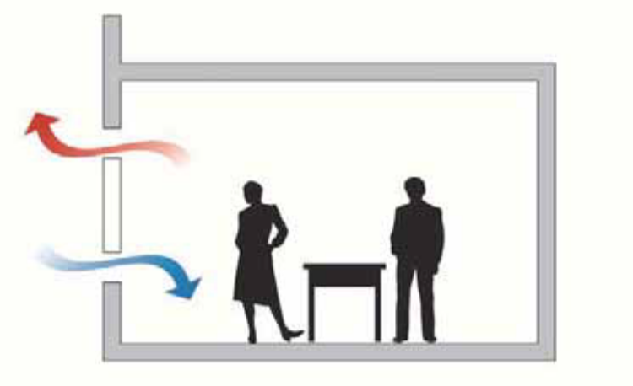
Single sided ventilation – via opening window, drawing air in by natural convection currents. This air will typically mix with warm air rising from radiators, etc.
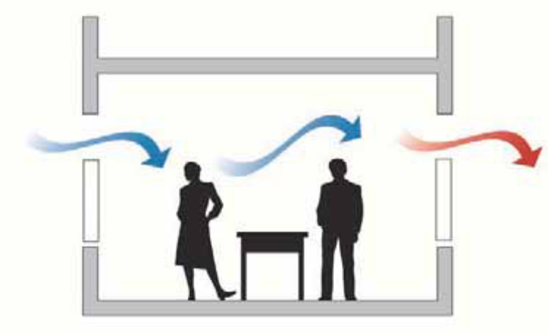
Cross Ventilation, could also draw fresh air from a central corridor or atrium. See Mechanical Supply Only below.

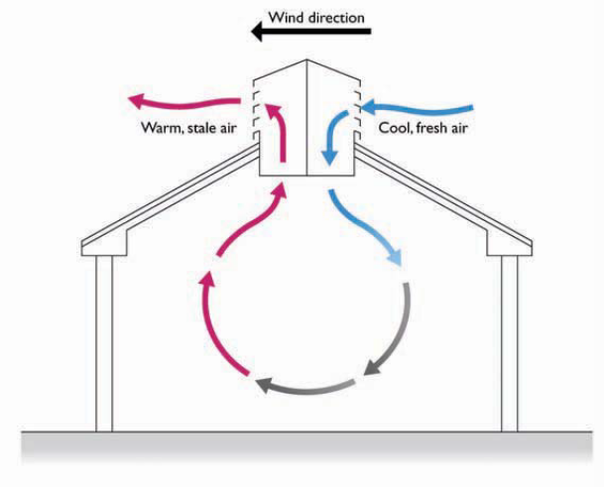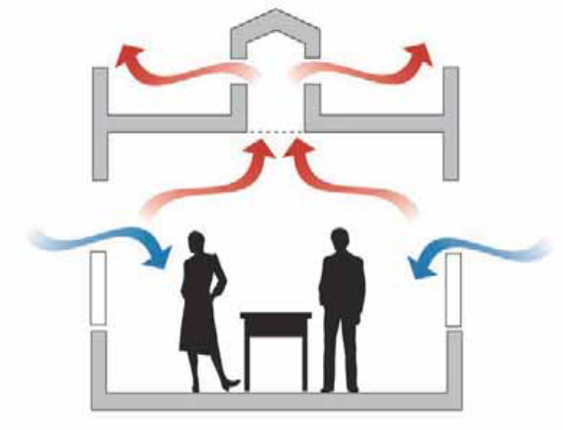
Passive Ventilation, such as "Windcatcher" on the left and "Stack" effect on the right, use a combination of natural convection and wind speed to draw fresh air in. They can also incorporate supply fans, to supplement supply air when wind direction or strength fluctuates and typically include external weather sensing, and automated controls.
"As Installed Records" and Service Records should be reviewed to identify the type of system in use

Typical Window Styles

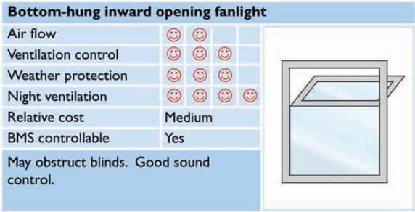 | 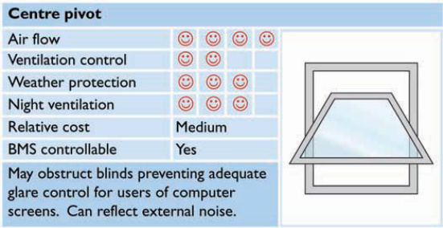
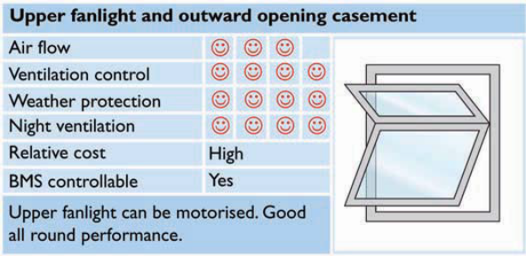 | 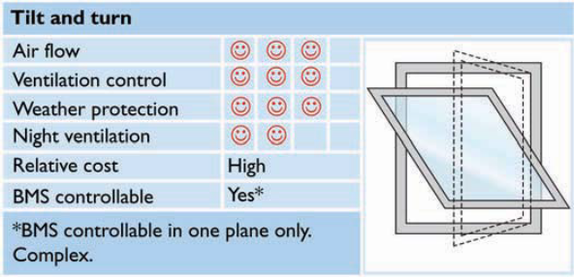
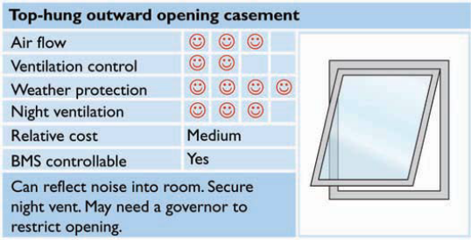 | 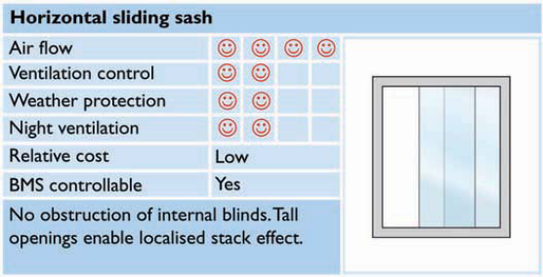
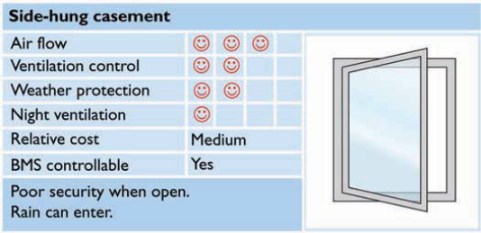 | 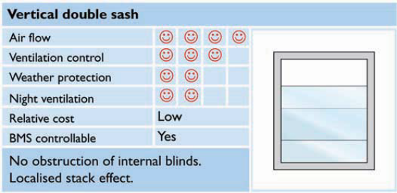

Mechanical Ventilation
Some mechanical systems can be concealed with the building fabric, ceiling spaces etc, but there will be elements on show
Mechanical – Extract only (MEO) – typically used in kitchens, bathrooms/toilets, sluice rooms, etc., and reliant on windows, doors, etc being open, or having been fitted with transfer grilles, should security be an issue. Typical examples, a wall mounted fan or a canopy over catering equipment, alternatively the fan may be positioned remotely, to reduce noise and only the grille will be visible, on the wall or ceiling.
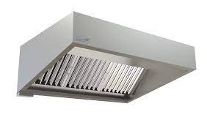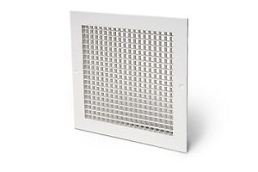
Mechanical - Supply Only –, as per this example of a large supply fan unit, used to provide air to a central atrium or corridor. Or smaller fans, installed in a wall or window to provide extra ventilation to the room, e.g. a kitchen. In some instances, the controls for the fan will enable it to be switched between supply to extract, in which case the fan should be left in the supply mode.
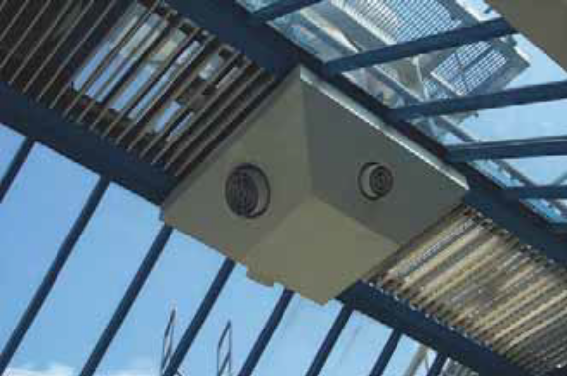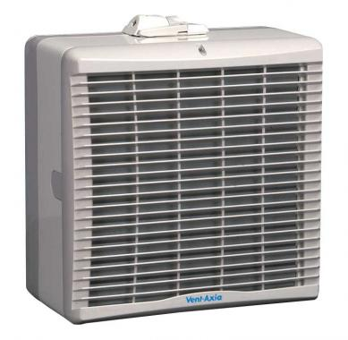

Additionally, Supply Only fans can be incorporated into units to provide cooling / heating to rooms, as the diagram below.
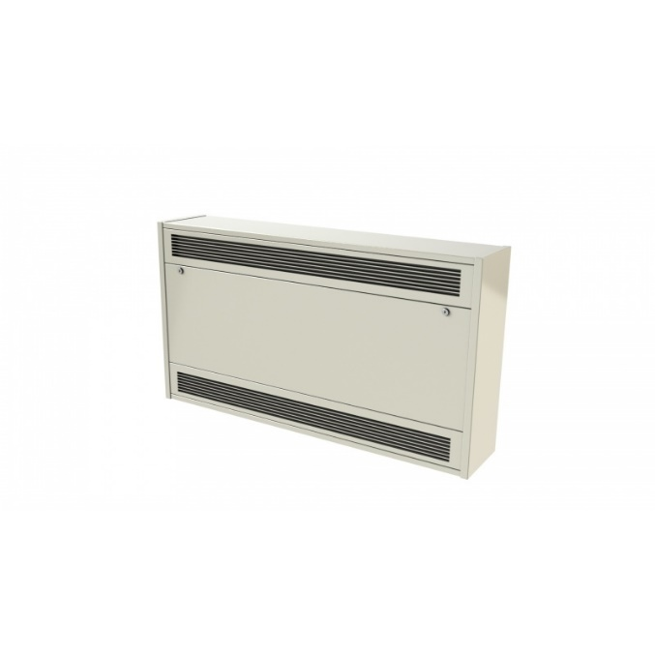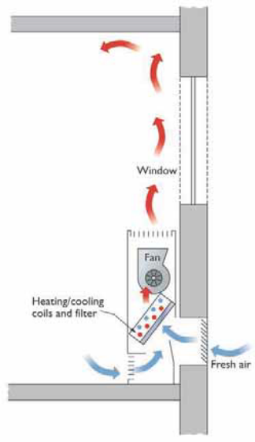

Mechanical - Supply and Extract (MSE), For ducted systems, typically concealed within a ceiling voids, only the grilles or diffusers will be visible.
Typical supply diffuser:-
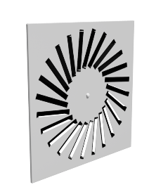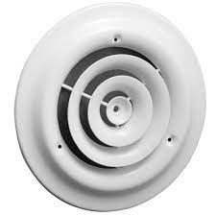

Typical extract grilles are simpler in design, as per the Extract Only example above.
The diffuser and grilles will be distanced from each other to draw air across the room.
Equally, the most basic system may not be ducted, or even concealed and would simply consist or a supply fan at one end of the room and an extract fan at the other.
Large rooms may be serviced with Air Handling Unit (AHU), which has both supply and extract fans within the same enclosure. Typically, the AHU will be remote from the room, possibly even roof mounted, with a series of rectangular ducts connected.
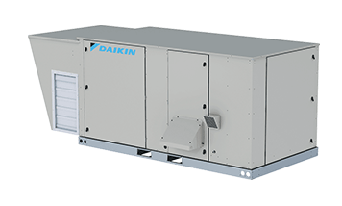

Mechanical – air conditioning – split system – no outside air.
These units recirculate the conditioned air back into the room and as such the occupation of the room should be limited. Such units should continue to run to prevent stagnation of the air. Periodically opening the door to the room will assist and introduce fresh air.
Such units will also have an external condenser unit and may also include the capability for heat recovery.
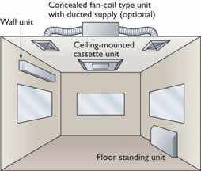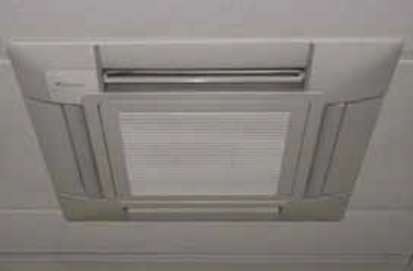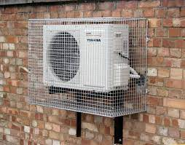

It should be noted that locations with Air Source, Ground Source Heat Pumps will have visually similar external equipment and the Service Records should be consulted to determine the type installed.
Mechanical - heat recovery (MHR)
Installations are generally concealed and therefore the layout of supply and extract grilles will resemble MSE and MAC systems. The waste heat from the extract air passed over a heat exchange matrix inside the unit, to temper the fresh supply air, thus creating free heating. These systems should be adjusted to minimise recirculated air and Service Records should be reviewed to identify the type of system in use.

Mechanical – air conditioning (drawing in outside air) (MAC)
As with MSE and MHR, MAC systems have characteristic multiple ceiling mounted diffusers and grilles and are generally used for larger open workspaces. The bulk of the system will be centralised plant, remote from the workplace, ducted to smaller units for local distribution and control of volume and temperature. Various other types of local units can be used, to suit particular applications, however the principle of a centralised supply and distribution to local outlets is the same. This diagram only shows the internal Supply Air ducting, for clarity. Service Records should be reviewed to identify the type of system in use.
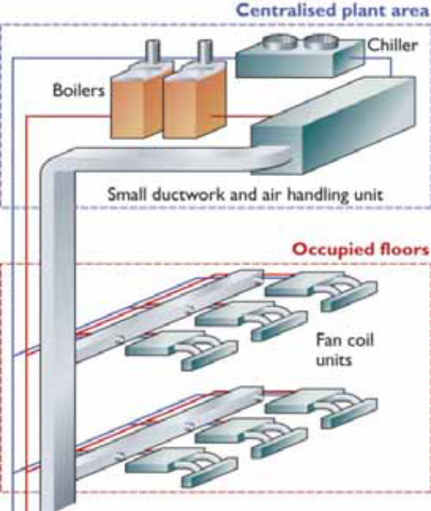

Specialist localised exhaust ventilation (SLEV) – typically used in workshops with an extract canopy or hood above each machine, welding bays, etc.
